Ex. No. 5 | JavaScript Form Validation
Date of Exercise | 12.10.2026
GitHub Host Link | https://praneettigga.github.io/web-tech-lab/
Aim
To design and develop two web forms, a Student Grade Calculator and a BMI Calculator, using HTML, CSS and JavaScript, where the input is validated in the browser and JavaScript functions with if / else decisions process the values and display the result, in the same green and beige theme used in the earlier experiments.
Description
Form validation: Form validation checks the data entered by the user before it is processed or sent to a server. Client-side validation gives instant feedback without a page reload, keeps empty or malformed values out, and avoids wasted requests. It improves usability, but the server must still validate the data again, because browser checks can be bypassed.
HTML5 built-in validation: The forms use the browser’s constraint validation. The required attribute blocks the submit while a field is empty, type="number" accepts only numeric input, min="1" rejects zero and negative values and step="0.1" allows decimals in the BMI form. When a rule fails, the browser shows a message and the submit event does not fire, so the JavaScript runs only for acceptable input.
Submit event and preventDefault: addEventListener("submit", …) attaches a function to each form. event.preventDefault() stops the normal page reload so the result can be shown on the same page.
Reading input: The entered values are read with getElementById(...).value and querySelectorAll(...). They are strings, so Number() converts them before any calculation.
Decisions with if / else: A chain of if / else if / else statements picks exactly one outcome. The Grade Calculator compares the average against 90, 80, 70, 60 and 50 to choose A+, A, B, C, D or F, and the BMI Calculator compares the BMI against 18.5, 25 and 30 to choose Underweight, Normal weight, Overweight or Obesity.
Functions and array methods: Each form handler is a function that runs when the form is submitted. The marks are collected into an array with the spread operator, converted with map(), and added with reduce() to get the total. The average is total divided by the number of subjects, and BMI is weight divided by the square of the height in metres.
Showing the result: The result box is hidden at first. After the calculation its innerHTML is set with a template literal, toFixed() rounds the numbers, and the hidden property is set to false to show it. aria-live="polite" lets screen readers announce the result.
External CSS: Both pages share css/style.css, which uses CSS variables, a card layout with a gold left border, a CSS grid for the input fields (two columns for the BMI form, collapsing to one column on narrow screens) and styled buttons and result boxes.
Procedure:
1. Select the forms to be built: a Student Grade Calculator and a BMI Calculator, with a page to choose between them.
2. Create a folder Expt5 with the sub-folders css and js.
3. Create index.html as a chooser page with links to grade-calculator.html and bmi-calculator.html, and link css/style.css.
4. Create grade-calculator.html with a form (id grade-form) containing five required mark fields named "mark", a Calculate Grade button, and an empty result div (id grade-result) that is hidden.
5. Create bmi-calculator.html with a form (id bmi-form) containing required number fields for height (cm) and weight (kg) with min="1" and step="0.1", a Calculate BMI button, and a hidden result div (id bmi-result).
6. Create css/style.css, reusing the colour variables, font, card and button styles of the earlier experiments, and add styles for the input grid, the result box and the chooser links.
7. In js/grade.js, select the form and result box and add a submit listener that calls event.preventDefault().
8. In the grade handler, read the five marks into an array with Number(), find the total with reduce() and the average, and use an if / else if ladder to choose the grade.
9. Display the total, average and grade in the result box using a template literal and show the box by setting hidden to false.
10. In js/bmi.js, add a submit listener that converts the height to metres, calculates BMI = weight / (height × height) and uses if / else if to find the category.
11. Display the BMI (rounded to one decimal place) and the category in the result box.
12. Open index.html in a browser, test the forms with empty, valid and boundary values, and check that the browser blocks empty or invalid input.
13. Push the code to GitHub and host it using GitHub Pages to obtain the deployment link.
Program
index.html
<!DOCTYPE html>
<html lang="en">
<head>
<meta charset="UTF-8" />
<meta name="viewport" content="width=device-width, initial-scale=1.0" />
<title>Experiment 5 Calculators</title>
<link rel="stylesheet" href="css/style.css" />
</head>
<body>
<main class="page-shell">
<section class="calculator-card chooser">
<h1>Simple Calculators</h1>
<p class="intro">Choose a form to get started.</p>
<div class="choice-links">
<a href="grade-calculator.html">Student Grade Calculator <span>→</span></a>
<a href="bmi-calculator.html">BMI Calculator <span>→</span></a>
</div>
</section>
</main>
</body>
</html>
grade-calculator.html
<!DOCTYPE html>
<html lang="en">
<head>
<meta charset="UTF-8" />
<meta name="viewport" content="width=device-width, initial-scale=1.0" />
<title>Student Grade Calculator</title>
<link rel="stylesheet" href="css/style.css" />
</head>
<body>
<main class="page-shell">
<section class="calculator-card">
<h1>Student Grade Calculator</h1>
<p class="intro">Enter marks out of 100 for five subjects.</p>

<form id="grade-form">
<div class="input-grid">
<label>Subject 1<input type="text" name="mark" min="0" max="100" required /></label>
<label>Subject 2<input type="text" name="mark" min="0" max="100" required /></label>
<label>Subject 3<input type="text" name="mark" min="0" max="100" required /></label>
<label>Subject 4<input type="text" name="mark" min="0" max="100" required /></label>
<label>Subject 5<input type="text" name="mark" min="0" max="100" required /></label>
</div>
<button type="submit">Calculate Grade</button>
</form>

<div id="grade-result" class="result" aria-live="polite" hidden></div>
<a class="back-link" href="index.html">← View BMI Calculator</a>
</section>
</main>
<script src="js/grade.js"></script>
</body>
</html>
bmi-calculator.html
<!DOCTYPE html>
<html lang="en">
<head>
<meta charset="UTF-8" />
<meta name="viewport" content="width=device-width, initial-scale=1.0" />
<title>BMI Calculator</title>
<link rel="stylesheet" href="css/style.css" />
</head>
<body>
<main class="page-shell">
<section class="calculator-card">
<h1>BMI Calculator</h1>
<p class="intro">Find your Body Mass Index using your height and weight.</p>

<form id="bmi-form">
<div class="input-grid two-columns">
<label>Height (cm)<input id="height" type="number" min="1" step="0.1" placeholder="e.g. 170" required /></label>
<label>Weight (kg)<input id="weight" type="number" min="1" step="0.1" placeholder="e.g. 65" required /></label>
</div>
<button type="submit">Calculate BMI</button>
</form>

<div id="bmi-result" class="result" aria-live="polite" hidden></div>
<a class="back-link" href="index.html">← View Grade Calculator</a>
</section>
</main>
<script src="js/bmi.js"></script>
</body>
</html>
css/style.css
:root {
--ink: #314339;
--heading: #244232;
--accent: #c5a56a;
--link: #496b55;
--border: #d8ccb4;
--surface: #fffdf8;
}

* { box-sizing: border-box; }

body {
min-height: 100vh;
margin: 0;
padding: 30px 20px;
color: var(--ink);
font-family: Georgia, serif;
background: #f4f0e7;
}

.page-shell { width: min(100%, 700px); margin: 0 auto; }

.calculator-card {
padding: 28px;
border: 1px solid var(--border);
border-left: 5px solid var(--accent);
border-radius: 10px;
background: var(--surface);
box-shadow: 0 4px 12px rgba(31, 77, 58, 0.08);
}

h1 { margin: 0; padding-bottom: 10px; border-bottom: 2px solid var(--border); color: var(--heading); font-size: 2rem; }
.intro { margin: 16px 0 24px; line-height: 1.5; }

.input-grid { display: grid; gap: 16px; }
.two-columns { grid-template-columns: repeat(2, 1fr); }
label { display: grid; gap: 7px; font-size: 0.92rem; font-weight: bold; }
input {
width: 100%;
padding: 8px;
border: 1px solid #b8a98a;
border-radius: 4px;
color: var(--ink);
font: inherit;
background: var(--surface);
}
input:focus { outline: 2px solid #e2c98e; border-color: var(--link); }
button {
margin-top: 22px;
padding: 8px 18px;
border: 1px solid var(--heading);
border-radius: 4px;
color: #fffaf0;
background: var(--heading);
cursor: pointer;
font: 1rem Georgia, serif;
}
button:hover { background: var(--link); }
.result { margin-top: 20px; padding: 14px; border: 1px solid var(--border); background: #f8f5ef; line-height: 1.6; }
.result strong { color: var(--heading); font-size: 1.1rem; }
.back-link { display: inline-block; margin-top: 24px; color: var(--link); text-decoration: none; }
.back-link:hover { text-decoration: underline; }
.choice-links { display: grid; gap: 14px; }
.choice-links a { display: flex; justify-content: space-between; padding: 14px; border: 1px solid var(--border); border-radius: 4px; color: var(--heading); background: #f8f5ef; text-decoration: none; font-weight: bold; }
.choice-links a:hover { border-color: #b8a98a; background: #e7ede4; }
.choice-links span { color: var(--link); }

@media (max-width: 460px) { .two-columns { grid-template-columns: 1fr; } }
js/grade.js
const gradeForm = document.getElementById("grade-form");
const gradeResult = document.getElementById("grade-result");

gradeForm.addEventListener("submit", (event) => {
event.preventDefault();
const marks = [...document.querySelectorAll('input[name="mark"]')].map((input) => Number(input.value));
const total = marks.reduce((sum, mark) => sum + mark, 0);
const average = total / marks.length;
let grade;

if (average >= 90) grade = "A+";
else if (average >= 80) grade = "A";
else if (average >= 70) grade = "B";
else if (average >= 60) grade = "C";
else if (average >= 50) grade = "D";
else grade = "F";

gradeResult.innerHTML = `Total: <strong>${total}/500</strong><br>Average: <strong>${average.toFixed(2)}%</strong><br>Grade: <strong>${grade}</strong>`;
gradeResult.hidden = false;
});
js/bmi.js
const bmiForm = document.getElementById("bmi-form");
const bmiResult = document.getElementById("bmi-result");

bmiForm.addEventListener("submit", (event) => {
event.preventDefault();
const heightInMetres = Number(document.getElementById("height").value) / 100;
const weight = Number(document.getElementById("weight").value);
const bmi = weight / (heightInMetres * heightInMetres);
let category;

if (bmi < 18.5) category = "Underweight";
else if (bmi < 25) category = "Normal weight";
else if (bmi < 30) category = "Overweight";
else category = "Obesity";

bmiResult.innerHTML = `Your BMI is <strong>${bmi.toFixed(1)}</strong><br>Category: <strong>${category}</strong>`;
bmiResult.hidden = false;
});
Output
Calculator chooser page
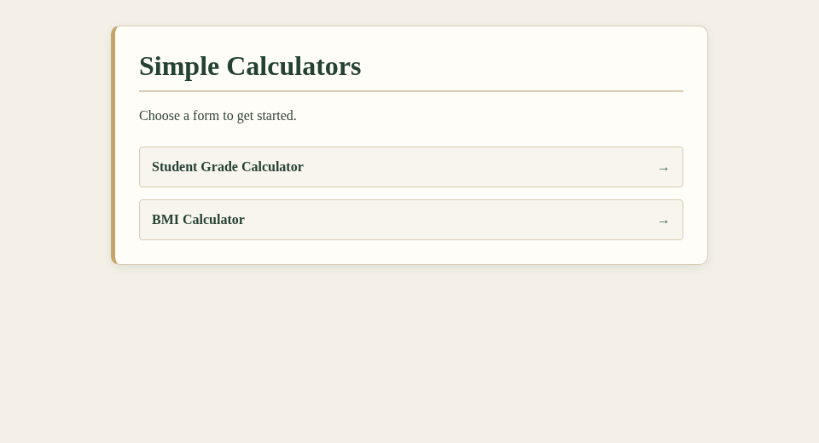
Figure 1: Chooser page (index.html)
Student Grade Calculator (empty form)
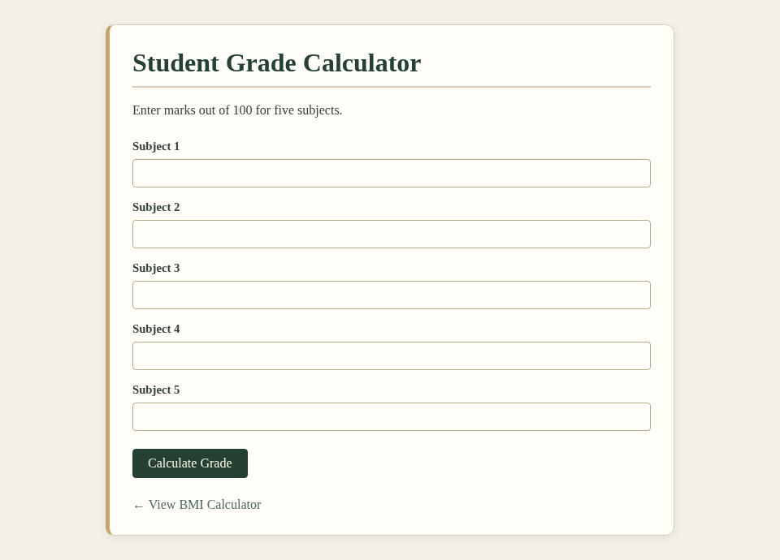
Figure 2: Grade Calculator (empty form)
Student Grade Calculator (result)

Figure 3: Grade Calculator with marks 85, 78, 92, 67 and 88
BMI Calculator (empty form)
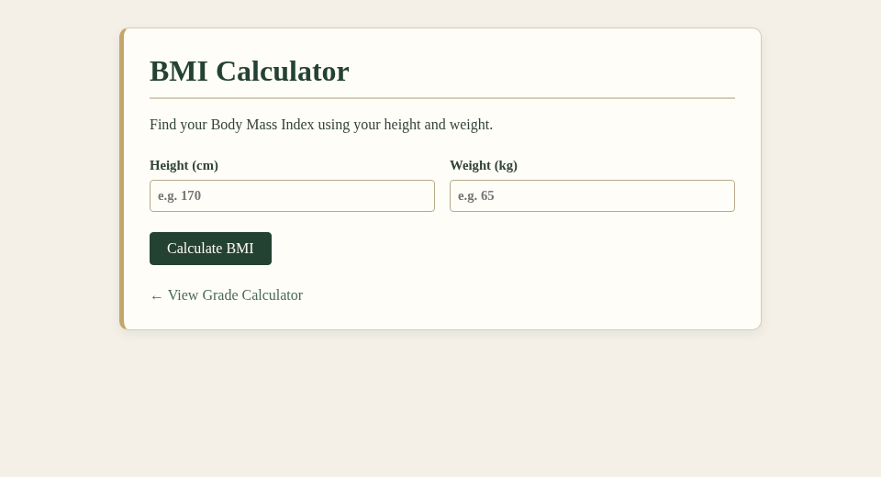
Figure 4: BMI Calculator (empty form)
BMI Calculator (result)
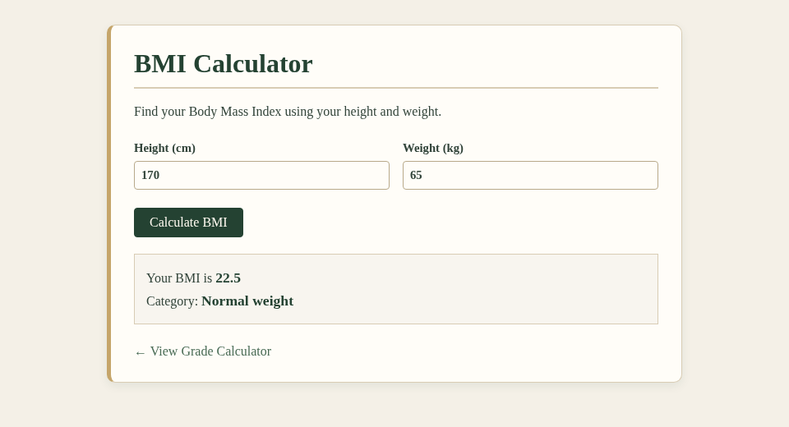
Figure 5: BMI Calculator with height 170 cm and weight 65 kg
Result
The Student Grade Calculator and the BMI Calculator were successfully designed and executed using HTML, CSS and JavaScript. The browser’s built-in validation blocked empty and invalid input, and JavaScript functions with if / else decisions calculated and displayed the total, average and grade (410/500, 82.00%, grade A for the sample marks) and the BMI and category (22.5, Normal weight for 170 cm and 65 kg).

